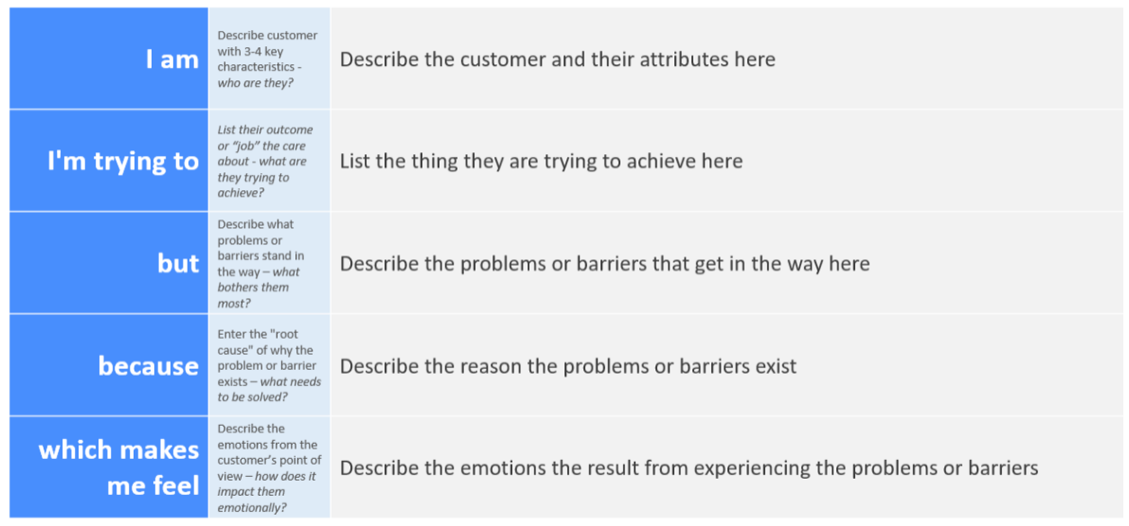
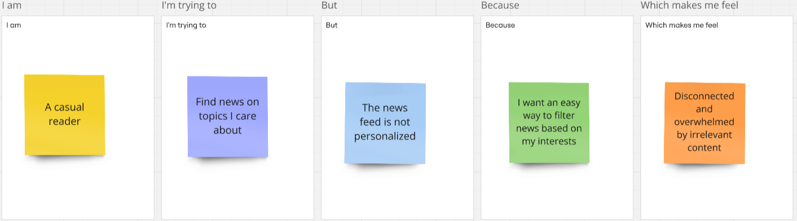
InsightStream: Navigate the News Landscape
Ideation Phase
Define the Problem Statements

Date | 5 March 2025
Team ID | SWTID1741155597
Project Name | News App
Maximum Marks | 2 Marks

Customer Problem Statement Template:
Create a problem statement to understand your customer's point of view. The Customer Problem Statement template helps you focus on what matters to create experiences people will love.
A well-articulated customer problem statement allows you and your team to find the ideal solution for the challenges your customers face. Throughout the process, you’ll also be able to empathize with your customers, which helps you better understand how they perceive your product or service.
Reference: https://miro.com/templates/customer-problem-statement/
Example:

Problem Statement (PS) | I am (Customer) | I’m trying to | But | Because | Which makes me feel
PS-1 | A busy professional | Stay updated with the latest news quickly | Most news websites are cluttered with ads and unnecessary content | I need a clean, distraction-free interface with only relevant news | Frustrated and unwilling to browse for long
PS-2 | A casual reader | Find news on topics I care about | The news feed is not personalized | I want an easy way to filter news based on my interests | Disconnected and overwhelmed by irrelevant content
PS-3 | A mobile user | Read news on the go | Many platforms are not mobile-friendly or take too long to load | I need a smooth, fast-loading, and responsive experience | Annoyed and likely to leave the platform
PS-4 | A user concerned about credibility | Get reliable news from trusted sources | A lot of platforms spread misinformation or lack source transparency | I need verified news from reputable sources | Skeptical and unsure which news to trust

